**Research**

***Facilities:***

* Restaurant
  + 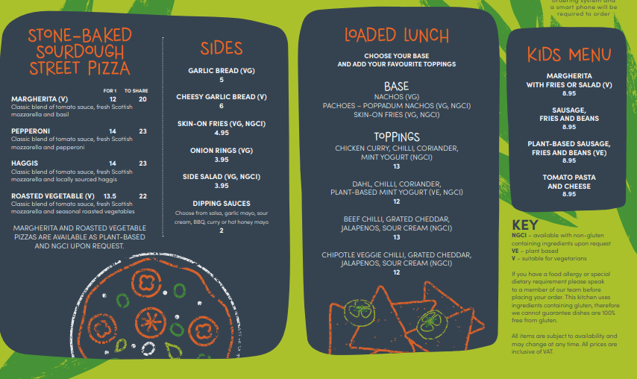
  + 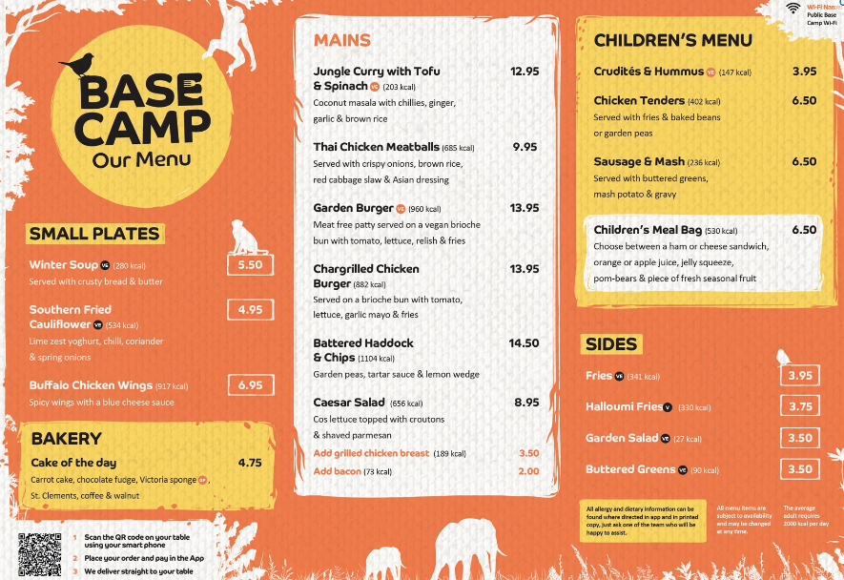
  + 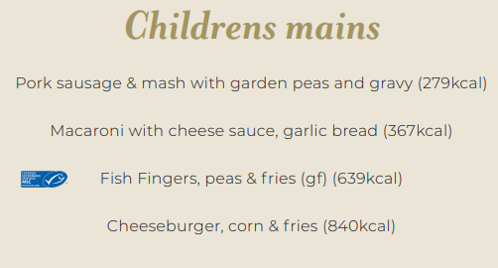
  + 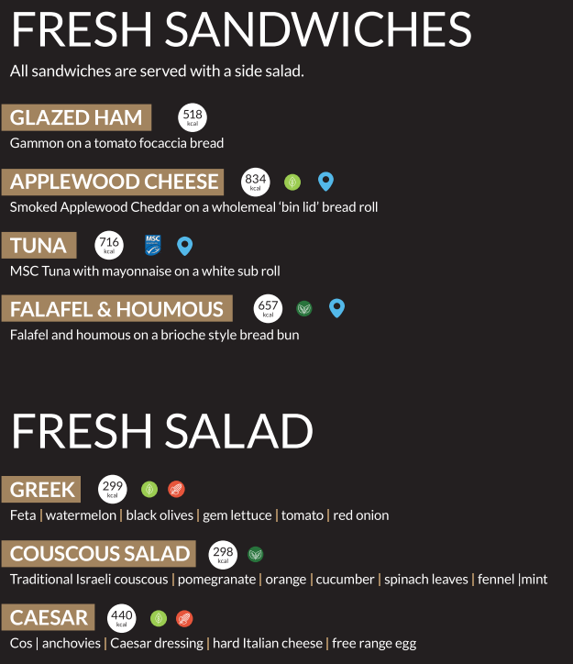
  + 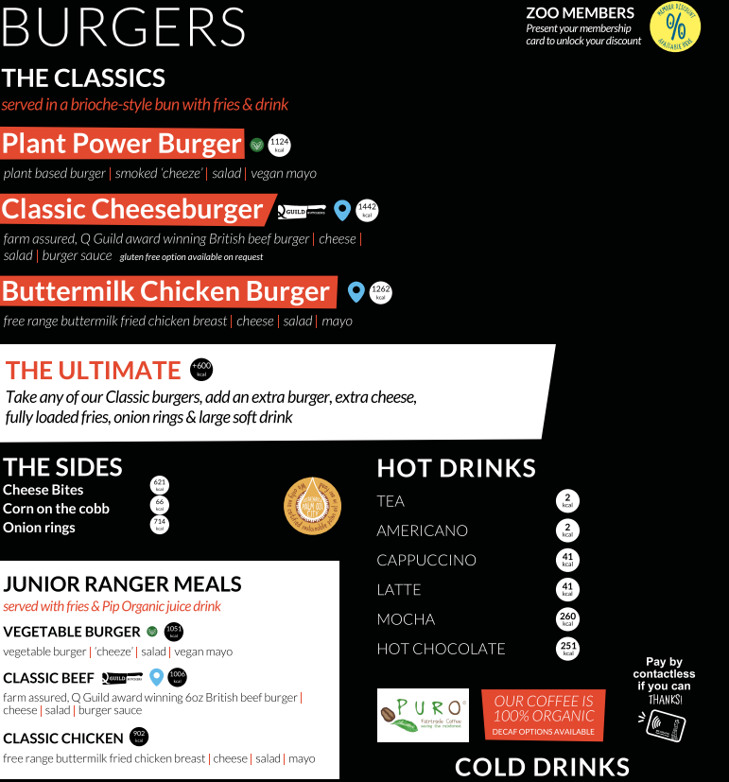
  + 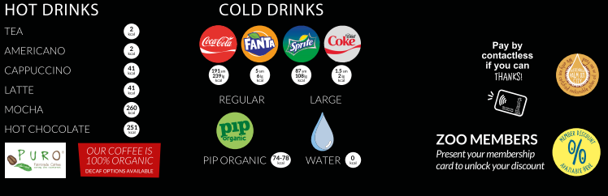
  + 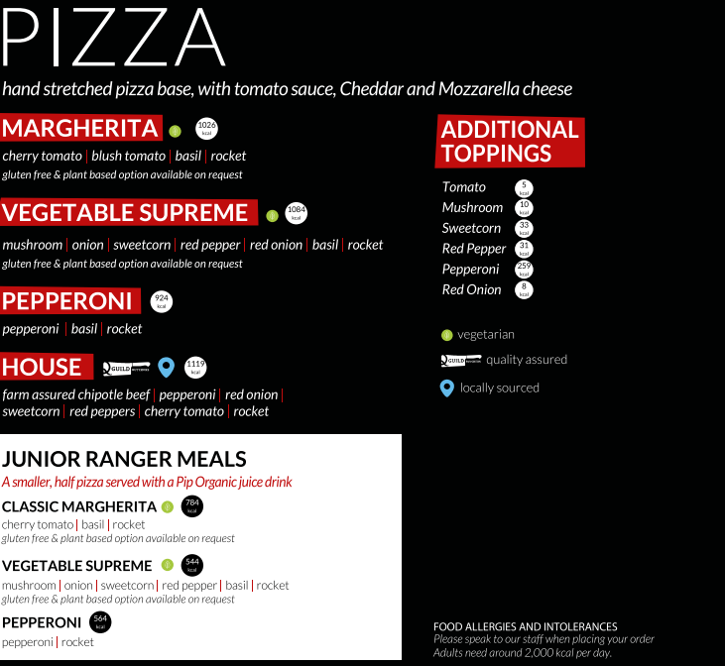
  + 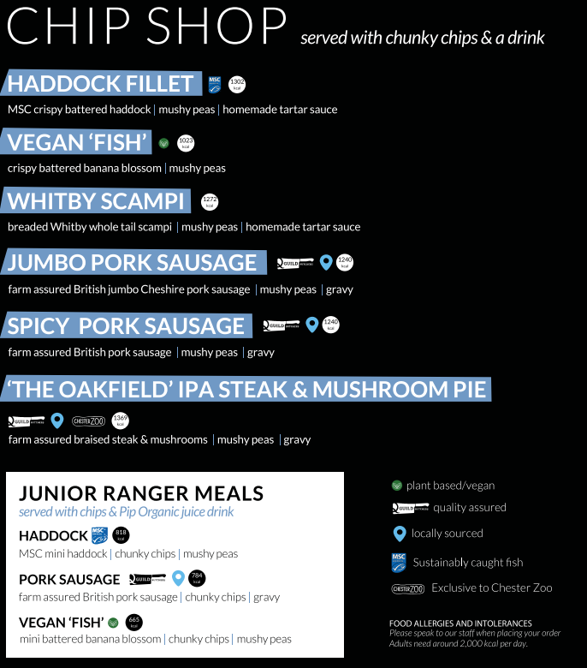
  + 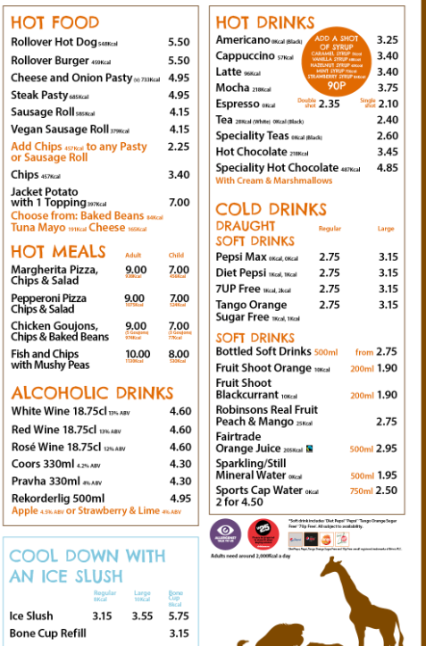
  + 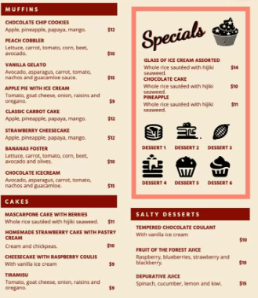
  + 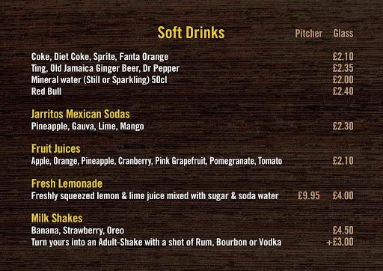
  + 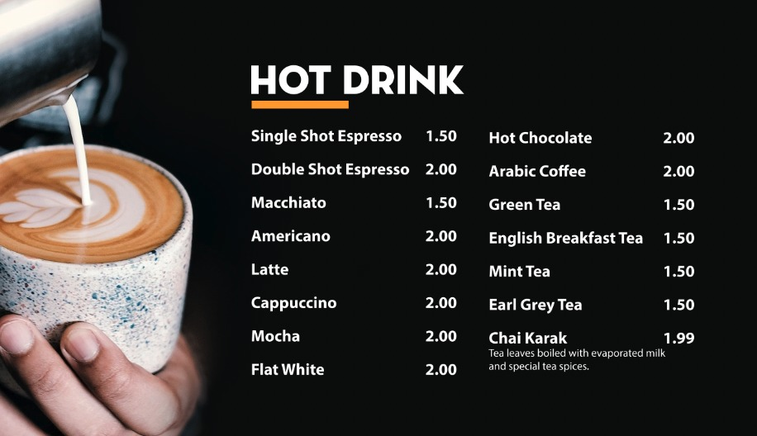
* Café
  + Drinks
    - Soft drinks - £1.85
    - 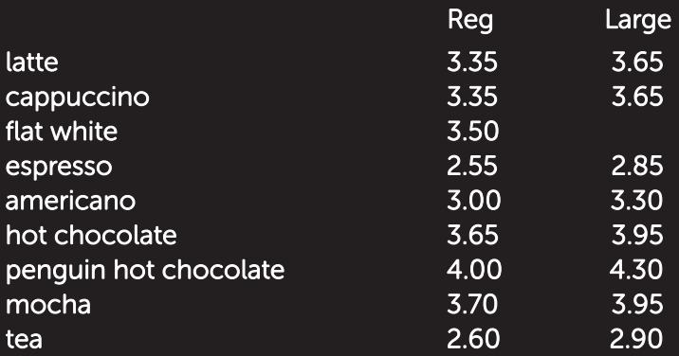
  + Food
    - Soup of the day - £3.95
    - Cheese toastie - £3.95
    - Other toasties - £4.95
      * Cheese and ham
      * Cheese and bacon
      * Cheese and tomato
      * Cheese and onion
      * Cheese and chicken
    - Cheese panini - £3.95
    - Other panini - £4.95
      * Tuna melt
      * Ham and cheese
      * Tomato and mozzarella
      * Tuna
      * Ham
      * Chicken
    - Sweet and savoury pastries – from £1.95
    - Sandwiches – from £3.95
    - Kid lunch bag - £5.95
    - Crisps - £1.45
* Food kiosks
  + Dotted around the zoo there are multiple kiosks that serve different snacks with a selection of drinks. These kiosks include:
    - Ice cream
    - Candy floss and sweets
    - Waffle
    - Pancakes/crepes
    - Sandwich
    - Hot dog
    - Burger
    - Loaded chips
* Picnic areas
  + Lots of picnic benches have been provided in designated picnic areas to allow for customers to experience the joy of getting to eat outside in nature.
* Play areas
  + A place for children to use up their energy and play in a safe environment. For safety, please make sure that children are supervised at all times.
* Gift shop
  + Our gift shop has something for everyone whether it is personalised trinkets, sweet treats or high-quality toys.